

**Instituto Politécnico Nacional**

**ESCOM “Escuela Superior de Cómputo”**

INGENIERÍA EN SISTEMAS COMPUTACIONALES

*Análisis Fundamental de Circuitos*

*Práctica 7*

Profesor: Figueroa Del Prado Felipe De Jesus

INTEGRANTES:

Rojas Alvarado Luis Enrique

Rodríguez Hernández Aldo Hassan

Quintana Camacho Rubén Abiasaf

Index

**Objective** **2**

**Material 2**

**Equipment 2**

**Theoric Introduction 2**

**Experimental progress 3**

**Calculations 3**

**Circuit simulations 4**

**Comparative of calculated, measured and simulated values 4**

**Questionary 6**

**Inferences 6**

**Bibliography 6**

# Objective

The student will identify the circuit known as the "Voltage Divider Circuit" in its simplest form. It will understand the concept of "Voltage Division" and will make the comparison between the calculated values and the measured values in each of the associated elements in the circuit of the practice. You will understand the usefulness of these circuits both in the analysis of more complex networks and in applications where accuracy and high values of current consumption are not required.

Deduce the expression of the current in each resistor as a function of the total current that enters the circuit and that is supplied by the voltage source. Basically apply all of the above, and in the measurement part realize that everything that is applied in these circuits, are not very complex to assemble and understand their behavior

# Material

* Breadboard
* 2 resistors (2200 Ω)
* 1 resistor (560 Ω)
* 1 resistor (470 Ω)
* 1 resistor (3300 Ω)
* 2 resistors (1000 Ω)
* 1 potentiometer (10000 Ω)
* 4 points banana-caiman
* 4 points caimán-caiman

# Equipment

* Digital multimeter
* Variable voltage source

# Theoric Introduction

## Voltage division

It is used to calculate the voltage of one of the resistors that have been joined in a series arrangement, depending on the voltage of the array. If there are no resistors in series it is not possible to apply voltage divider.

## Two resistors in series

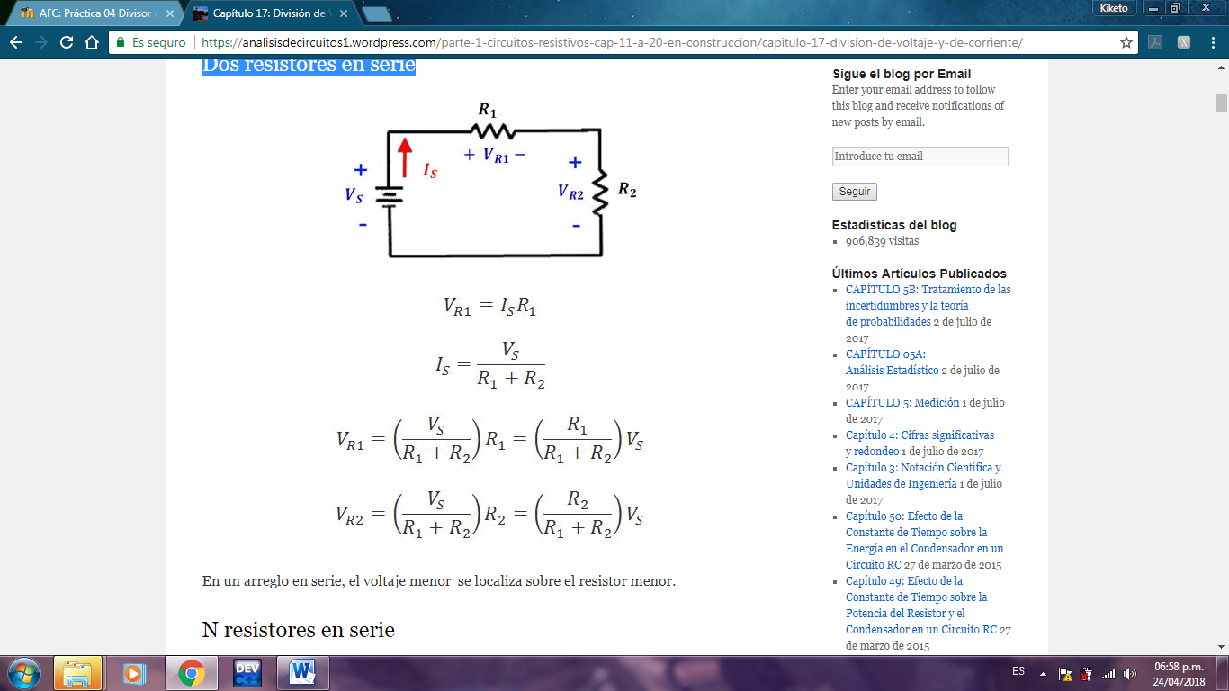



## Current division

The dual of the voltage division is the division of current.

It is used to calculate the current of one of the resistors that have been joined in a parallel arrangement, as a function of the array current. If there are no resistors in parallel, it is not possible to apply current division.

## Two resistors in parallel

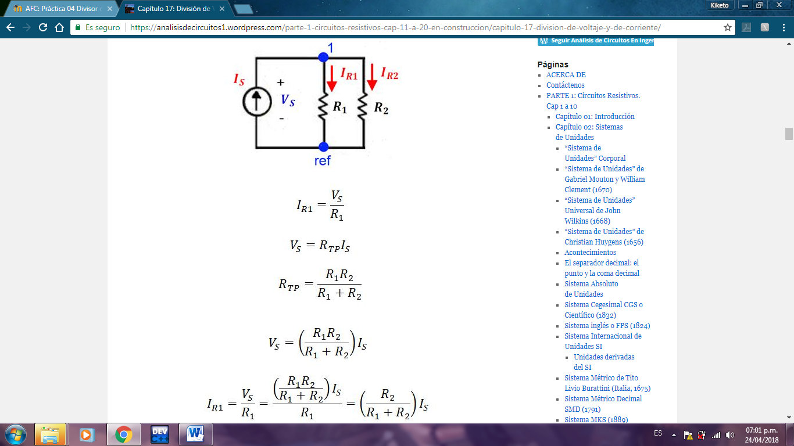

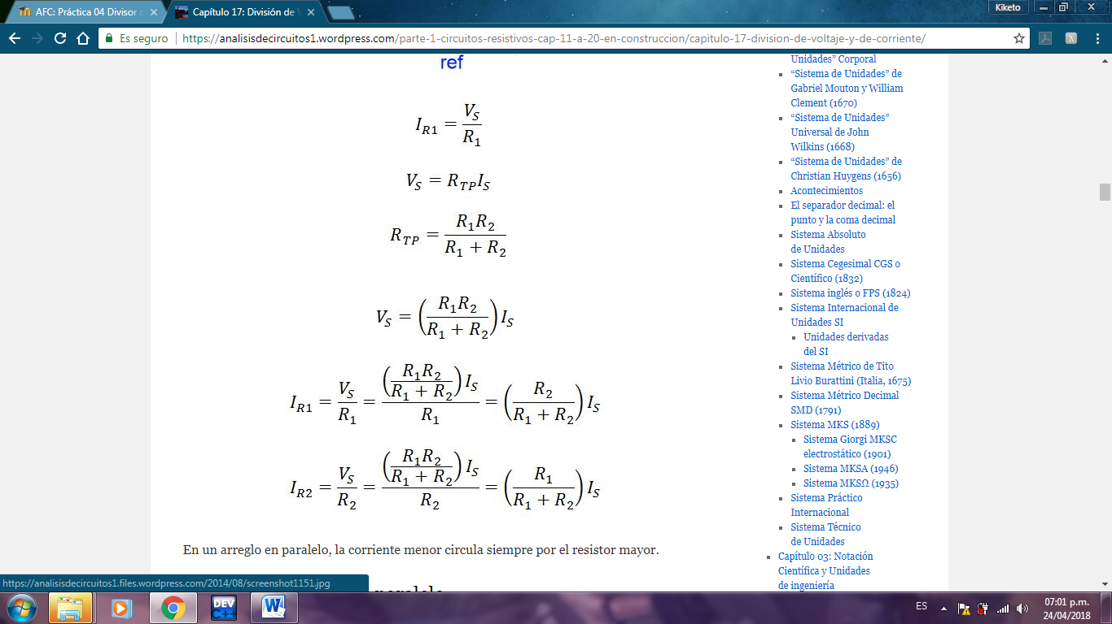

# Experimental progress

# Having the elements connected as required by practice, we proceeded to measure voltages of each element of the circuit by connecting the voltmeter in parallel with each of the resistances, and this made the values received in a table.

# The same was done with the currents, but this was measured in series in the whole circuit and the given values of each of the elements were written down in a table and the differences were taken to see the error that marked each element

# Calculations

## Voltage divisor calculations

For voltage divider calculations, it is required to first obtain the total resistance to find the value of the current that passes through the circuit. once the current is obtained, the voltage of each resistance is obtained using the ohm law

## Current divisor calculations

|  |  |
| --- | --- |
| IR1 | 6.37 mA |
| IR2 | 3.63 mA |
| IR3 | 1.65 mA |
| IR4 | 1.1 mA |

# Circuit simulations

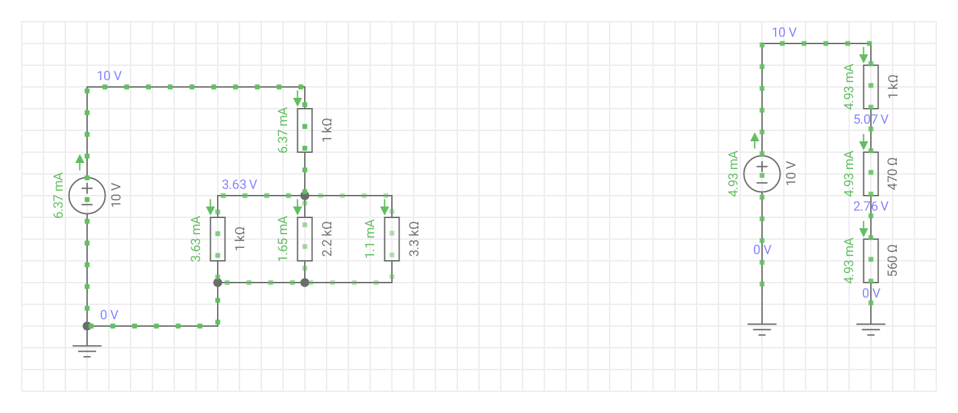



# Comparative of calculated, measured and simulated values

## Voltage divisor table

|  |  |  |  |  |
| --- | --- | --- | --- | --- |
| Voltage | Theoric value | Measured value | Simulated value | Error ΔV Ó ΔI |
|  | 4.92 V | 1.56 V | 4.93 V | -3.36 V |
|  | 2.37 V | 7.6 V | 2.32 V | 5.29 V |
|  | 2.75 V | 0.87 V | 2.76 V | 1.88 V |
|  | 10 V | 10 V | 10 V | 0 V |
|  | 5.08 V | 7.6 V | 5.07 V | 2.52 V |
|  | 2.77 V | 0.86 V | 2.76 V | -1.91 V |
| V Total | 27.89 V | 28.49 V | 27.84 V | 4.42 V |

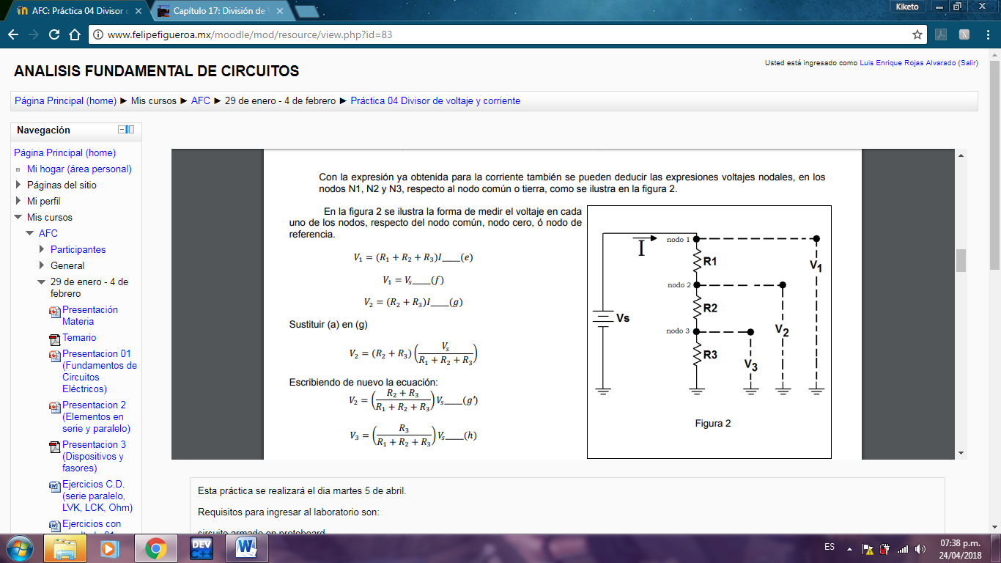

From figure 2 if R1 = 1k and R2 = 2.2k that value of R3 is necessary to have a voltage V3 = 5V if Vs = 10V, build the circuit and if necessary make a resistor array or use a potentiometer and check

R3 = 1.47 kΩ

Construct a voltage divider circuit like the one shown in figure 2 with Vs = 10V so that it obtains the following voltage values that are requested in table No. 2 (the values of the resistors must be calculated before entering the laboratory to be able to buy them, propose a value in R1 and calculate the other two).

## Table 2

|  |  |  |  |
| --- | --- | --- | --- |
| Voltage | R1 | R2 | R3 |
| V2 = 5V | 1 KΩ | 440 Ω | 560 Ω |
| V3 = 3V | 1 KΩ | 470 Ω | 630 Ω |

## Current divisor table

|  |  |  |  |
| --- | --- | --- | --- |
| Current | Theoric value | Measured value | Error ΔI |
| IR1 | 6.37 mA | 6.4 mA | 0.03 mA |
| IR2 | 3.63 mA | 3.4 mA | 0.23 mA |
| IR3 | 1.65 mA | 1.62 mA | 0.03 mA |
| IR4 | 1.1 mA | 1.2 mA | 0 mA |
| Total | 12.75 mA | 12.62 mA | 0.29 mA |

# Questionary

1.- What is the reason for the existence of the error or deviation of the measured value from the calculated value?

• That some components (in this case resistance) do not have the value indicated at the factory since they have an approximate value or close to the one stipulated, which causes data somewhat distant from the expected

2.- What is the utility of the "voltage divider" for the analysis of electrical circuits?

• The voltages in an electric circuit can be more easily calculated since the output voltages are only fractions of the input voltages.

3.- What is the utility of the "current divider" for the analysis of electrical circuits?

• It is easier to calculate currents that pass through different sites of the circuit only by calculating the output currents and thus be able to obtain the current that passes through each element

4.- Can the voltage and current divider circuits be extended to a greater number of resistors?

• Yes

5.- If the voltages in each node were required with predetermined specific values, what should be done to obtain said values?

• Equal the equation to this value and only clear some voltage that is required

# Inferences

* Quintana Camacho Rubén Abiasaf

Thanks to the knowledge acquired in class on this subject, we had greater ease of completing the practice satisfactorily because with a very well-armed circuit and we knew how to measure currents and voltages in more difficult circuits. This is important to quickly determine some voltage and current value without having to take a circuit reduction

* Rojas Alvarado Luis Enrique

Physically when measuring the current and voltage is applied practically as we normally would, the voltage according to the nodes that are in the circuit and the current measured in series to know what is happening in each loop of the circuit.

* Rodríguez Hernández Aldo Hassan

We realized that when measuring the current divider, it divides when it is in parallel but it is joined again in the node, in the case of the voltage divider when it is in series is when it is divided in each resistor

# Bibliography

1. [**https://analisisdecircuitos1.wordpress.com/parte-1-circuitos-resistivos-cap-11-a-20-en-construccion/capitulo-17-division-de-voltaje-y-de-corriente/**](https://analisisdecircuitos1.wordpress.com/parte-1-circuitos-resistivos-cap-11-a-20-en-construccion/capitulo-17-division-de-voltaje-y-de-corriente/)